Shallow copy and deep copy
In JavaScript, copying objects can be done in two ways: shallow copy and deep copy.
Shallow Copy
A shallow copy creates a new object with the same reference to the original object. If we change the second object the first object also will modify

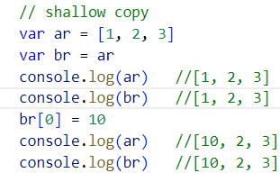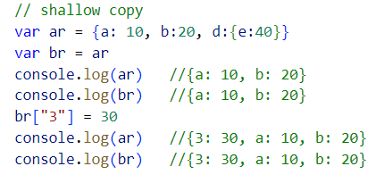

A deep copy creates a new object with the same properties as the original object, and created a new reference/memory address
If we change the second object the first object will not modify
Using spread, slice for array and loop
Using Object.assign({}, object reference for properties)
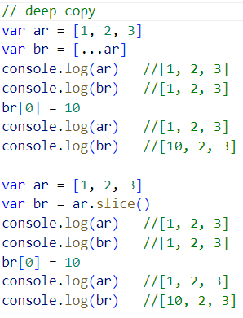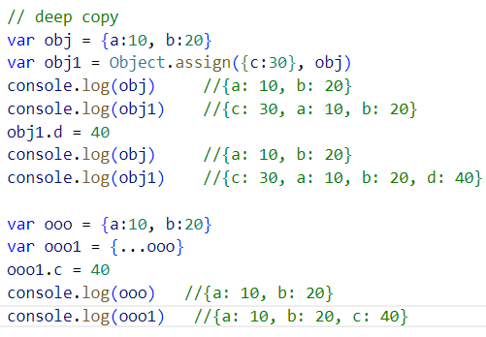

When your dealing with nested objects if u modify the second object nested value, the browser will display the first object as modified but if we use json.stringify() it is show as it is
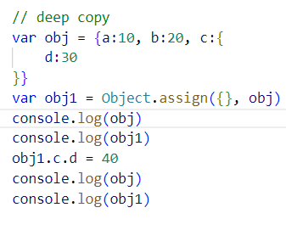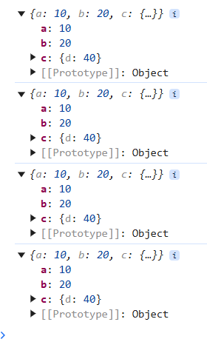
When your dealing with nested objects the json.stringify() is help us to see the original object instead of modified object
